Rendering Lists with Signals and @for
In this exercise, you will
- Make the application reactive by connecting it to signal
- Render the product list dynamically

- Continue from previous store application. Make sure that the Terminal Server is there and run the web project.
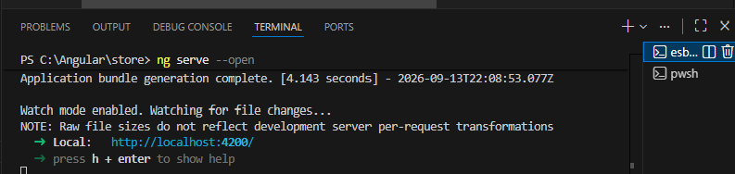

- Should have another Terminal window ready for other task. In this Terminal window, we will generate a product interface (model) by running command ng g i products/product
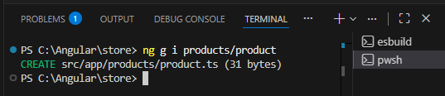
- In the newly create producs\product.ts file, type
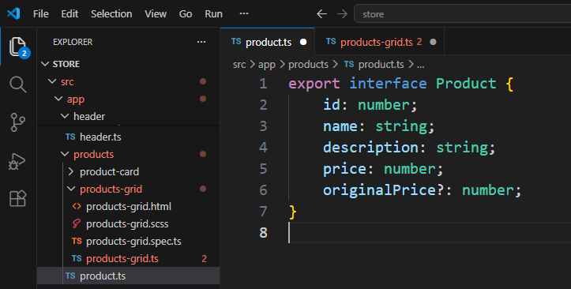
Note: originalPrice is nullable

- Next, we will create a signal under products-grid component. In products-grid.ts file,
import { Component, signal } from '@angular/core';
import { ProductCard } from '../product-card/product-card';
import { Product } from '../product';
import {MatIconModule} from '@angular/material/icon';

@Component({
selector: 'app-products-grid',
imports: [ProductCard, MatIconModule],
templateUrl: './products-grid.html',
styleUrl: './products-grid.scss',
})
export class ProductsGrid {
protected readonly products = signal<Product[]>([
{
id: 1,
name: "Durian",
description: "The king of fruit",
price: 35.0,
originalPrice: 50.0,
},
{
id: 2,
name: "Nenas",
description: "Unique fruit from Johor",
price: 8.0,
},
{
id: 3,
name: "Dokong",
description: "Imported fruit from Thailand",
price: 12.0,
}
]
)
}

- Amend the template file products-grid.html
<div class="products-container">
Total Products: {{ products().length}}

<div class="products-grid">
@for (product of products(); track product.id){
<app-product-card />
}@empty {
<div class="empty-state">
<mat-icon>inventory_2</mat-icon>
<h3>No products available</h3>
<p>Check back later for new arrivals!</p>
</div>
}
</div>
</div>

- Prepare scss file for the products-grid companent
.grid{
display: grid;
grid-template-columns: repeat(auto-fill, minmax(280px, 1fr));
gap: 16px
}

.products-grid {
display: grid;
grid-template-columns: repeat(auto-fill, minmax(280px, 1fr));
gap: 16px
}

.empty-state{
grid-column: 1 / -1;
display: flex;
flex-direction: column;
align-items: center;
justify-content: center;
padding: 4rem 2 rem;
text-align: center;

mat-item{
font-size: 4rem;
width: 4rem;
color: var(--mat-sys-outline);
margin-bottom: 1rem;
}

h3{
margin: 0 0 0.5rem;
color: var(--mat-sys-on-surface);
}

p{
margin: 0;
color: var(--mat-sys-on-surface-variant);
}
}
- Save All, now the web page should look like this
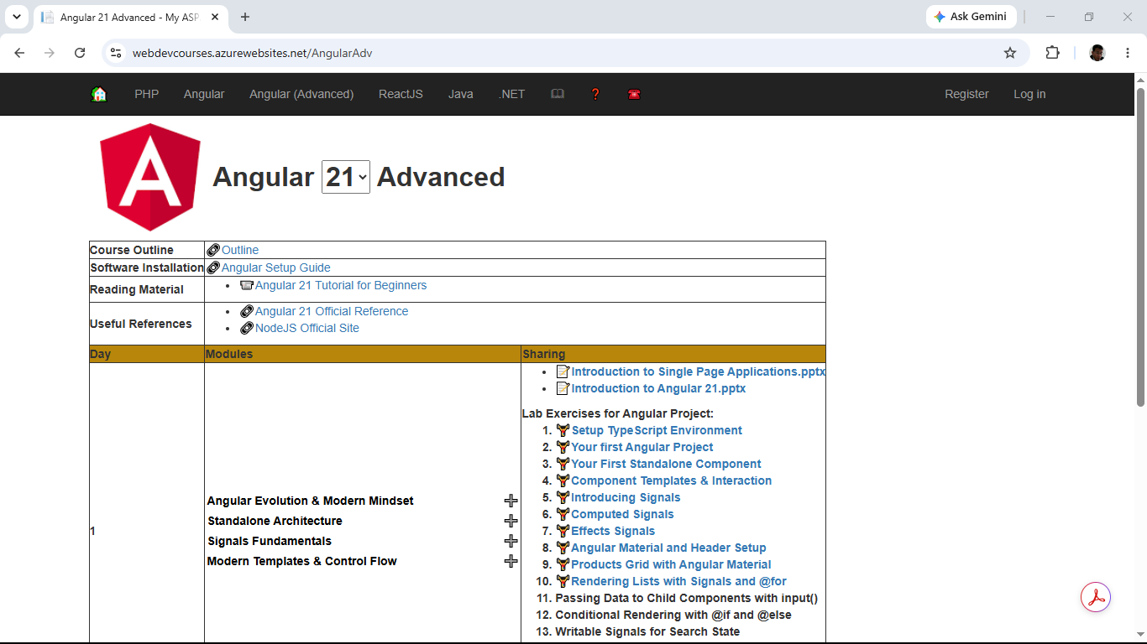

- Try comment the sample product in products-grid.ts and save it
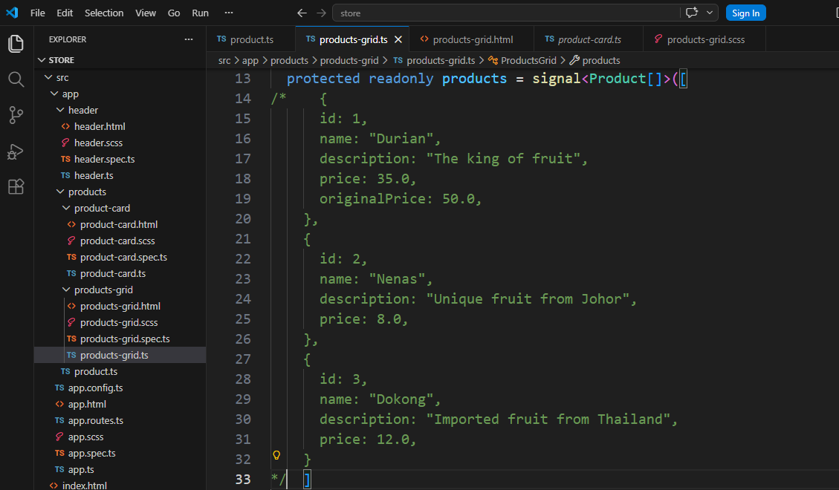
Now, the browser should show
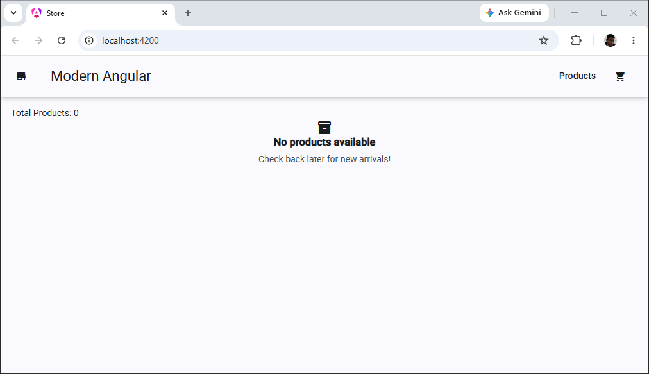

- Uncomment products. Save products-grid.ts

- Close VS Code

- Backup/Zip the application as store(Ex10).7z

